**Calling**

In a land of Castles, Canals and Churches there was a small Kingdom by the name of Brinklow. All that the Kingdom lacked was its very own Prince and Princess.

**Prince and Princess Competition**

**Saturday 12Th September**

**all PRINCES & Princesses**

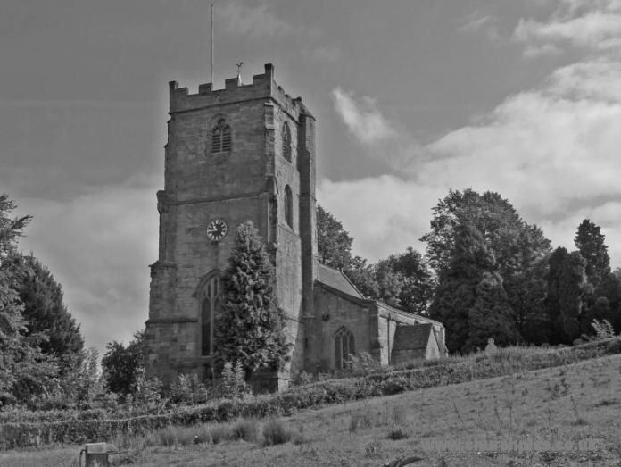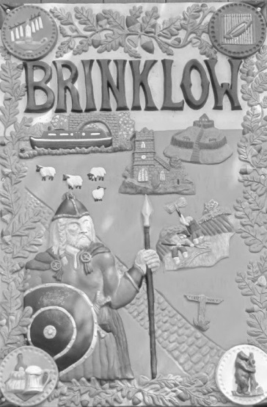

So the wise people of the village assembled and decreed a competition (fancy dress optional) would be held on



Entry forms also available from:

Pumpkins Deli in Brinklow

and Brinklow Post Office/General Store

**Sunday**

**11th September 2016**

**at Brinklow Fayre**

to select a Prince and Princess to serve the village for the next 12 months.

Categories: under 7 and 7 to 11 years

**Winning children will be required to participate in future village events for 12 months as the reigning Prince and Princess**

Entry fee £1 for each of first two children per family. Additional children free